**Customizable Email Templates**

*Announcement Template—Monthly Discussion*

[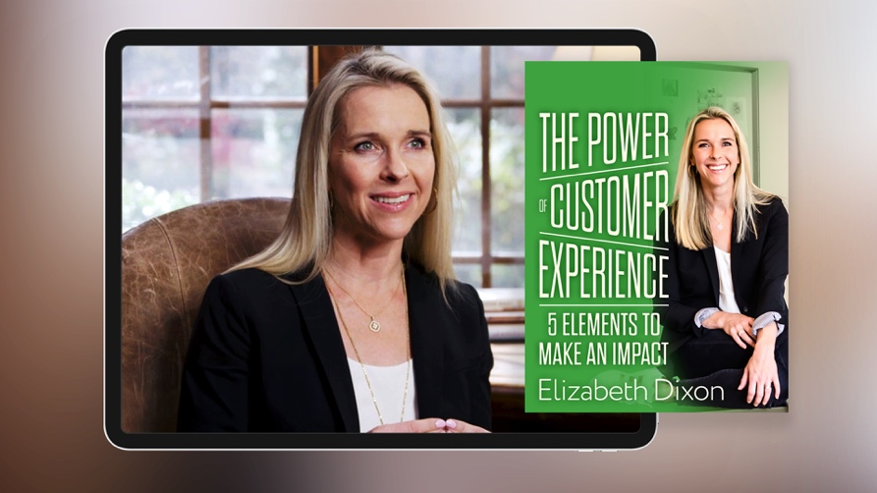](https://app.rightnowmedia.org/en/content/details/745918)

Team,

This month we’ll spend time as a team going through [*The Power of Customer Experience*](https://app.rightnowmedia.org/en/content/details/745918)withspeaker, author, and leader Elizabeth Dixon on RightNow Media @ Work. I chose this series to help us learn how we can embrace our unique potential to make an impact.

Over the next month, please find time to watch this seven-session series on your own. In addition to watching the series, note your answers the below questions. We may not discuss every question, but I would like each person to be prepared to give your input if asked.

* [REVIEW QUESTION BANK AND INCLUDE 5-6 QUESTIONS HERE]

Please complete everything prior to [DATE], which is when we will discuss this series in our team meeting. If you haven’t registered your free RightNow Media @ Work account yet, here’s the link to do so: [INSERT CUSTOM LINK—LOG IN TO YOUR ACCOUNT, CLICK ‘CONTACTS’ IN TOP RIGHT, THEN CLICK ‘COPY INVITE LINK’ BUTTON. CONTACT YOUR CONSULTANT FOR ADDITIONAL HELP OR QUESTIONS.]

Let me know if you have any questions. I look forward to discussing this series together.

*Announcement Template—Weekly Discussion*

](https://app.rightnowmedia.org/en/content/details/745918)

Team,

This month we’ll spend time as a team going through [*The Power of Customer Experience*](https://app.rightnowmedia.org/en/content/details/745918)withspeaker, author, and leader Elizabeth Dixon on RightNow Media @ Work. I chose this series to help us learn how we can embrace our unique potential to make an impact.

Each week you’ll watch 2-3 sessions from the series and make note of your answers to the questions for that session (provided via email). We’ll then get together each week to discuss those sessions and the team’s responses. For our first discussion on [DATE], consider these questions as you’re watching sessions 1 and 2:

* [REVIEW QUESTION BANK FOR SESSIONS 1 & 2 AND INCLUDE TWO QUESTIONS HERE.]

If you haven’t registered your free RightNow Media @ Work account yet, here’s the link to do so: [INSERT CUSTOM LINK—LOG IN TO YOUR ACCOUNT, CLICK ‘CONTACTS’ IN TOP RIGHT, THEN CLICK ‘COPY INVITE LINK’ BUTTON. CONTACT YOUR CONSULTANT FOR ADDITIONAL HELP OR QUESTIONS.]

Let me know if you have any questions. I look forward to discussing this series together.

*Reminder Template*

*Tip: You can reply all to your previous announcement email so your team has easy access to the questions you sent over in the original email.*

Team,

Just a reminder that we’ll be discussing [*The Power of Customer Experience*](https://app.rightnowmedia.org/en/content/details/745918) with Elizabeth Dixon at our team meeting [next week / tomorrow].

* Make sure you’ve signed up for your free RightNow Media @ Work account: [INSERT CUSTOM LINK]
* Watch [the series here](https://app.rightnowmedia.org/en/content/details/745918) (available on desktop, mobile, or TV streaming devices).
* Answer the questions I previously sent over in preparation for our discussion.

Let me know if you have any questions. I look forward to discussing this series together.

*Weekly Question Email Template*

Team,

For next week’s discussion, watch sessions [X and X] of [*The Power of Customer Experience*](https://app.rightnowmedia.org/en/content/details/745918) with Elizabeth Dixon. Consider these questions as you’re watching:

* [REVIEW QUESTION BANK FOR THIS SPECIFIC SESSION AND INCLUDE 2-4 QUESTIONS HERE.]

Let me know if you have any questions. I look forward to discussing this series together.

**Question Bank**

*From session 1:*

* What does it feel like to you when you are seen and served by someone else?
* What are some examples of seemingly small moments of connection you can make for others which your job?
* What benefits stand out to you for improving your brand's Customer Experience?

*From session 2:*

* What is your current mindset for:

Customers: _______________________________________________________________

Your Work: _______________________________________________________________

* What do you think the difference is between a mindset of "have to" vs. "get to"?
* Where do you want to see a change in results in your life?
* What behaviors do you need to have to get those results?
* What mindset do you need to have to support those behaviors?
* What would be the benefit to you/others if you experienced those results mentioned above?

*From session 3:*

* What are some cultural norms ("how we do it here") of your organization?
* What are you currently modeling, creating, and allowing that helps your culture?
* What are you currently modeling, creating, and allowing that hurts your culture?
* Who is someone in your life that you follow because of who they are, not the title they have?
* In this season, circle what applies to you:
* Personal Leader <––––––––––––––––––> Positional Leader
* Describe the culture you want to create around you.
* What do you need to consistently model, create and allow for that to be true?

*From session 4:*

* Complacent people create complacent companies and complacent companies never win.
* What does this mean to you?
* What do your customers need from your brand? What do they want more of? Less of?
* What brand can you imagine your life without? Why do you love them so much?

*From session 5:*

* When was the last time, as a customer, you had an average experience with a brand?
* Why was it average?
* What are ideas of signature moments for your brand?
* What are ideas of surprising moments for your brand?
* What are ideas of solvable moments for your brand?
* Do you see solvable moments as an opportunity or an obstacle?

*From session 6:*

* What is a current problem you are facing in your role?
* What is a solution you see to solve?

*From session 7:*

* Which of the 5 elements do you need to focus on in this season?
* What other benefits do you see when you improve on the 5 elements?
* Which of the benefits mean the most to you?

*Tip: Additional questions can be found in the free series study guide* [*on RightNow Media @ Work here.*](https://app.rightnowmedia.org/en/study-guide/2085/745923)